Curve-Prior-Guided Dual-View Latent Diffusion for Low-Light Image Enhancement
Abstract
Low-light image enhancement is essential for improving visual perception and supporting downstream vision tasks under insufficient illumination. However, existing curve-based approaches may amplify noise or cause local overexposure, whereas diffusion models usually lack explicit spatial exposure guidance, making it difficult to balance illumination correction, detail preservation, and artifact suppression. To address these issues, we propose CPD-LDM, a curve-prior-guided dual-view latent diffusion model. A frozen Zero-DCE generates a pre-enhanced view and pixel-wise curve parameters. Multi-scale gated fusion combines the original and pre-enhanced views under curve-prior guidance. A reliability-aware detail-denoising module separates informative high-frequency structures from uncertain noise, while a shared encoder projects conditional and target features into a unified latent space. Conditional diffusion restores the normal-light representation, which a guided decoder reconstructs using multi-scale conditional features. Extensive experiments on LOL-v1, LOL-v2-Real, and LOL-v2-Synthetic demonstrate that CPD-LDM achieves highly competitive performance in terms of PSNR, SSIM, and LPIPS. Qualitative comparisons further show more natural illumination, clearer structures, and fewer artifacts.
Keywords: low-light image enhancement, conditional diffusion, curve estimation, latent feature space.
1 Introduction
Images captured under insufficient or spatially non-uniform illumination often suffer from low brightness, reduced contrast, color distortion, detail loss, and amplified sensor noise. These degradations reduce visual quality and may compromise downstream tasks such as object detection, semantic segmentation, and scene understanding. Classical low-light image enhancement (LLIE) methods mainly rely on histogram adjustment, illumination correction, or Retinex decomposition. Multi-scale Retinex improves local contrast by separating illumination and reflectance information [1], while LIME estimates a spatial illumination map to perform adaptive brightness correction [2]. Nevertheless, handcrafted priors and fixed optimization procedures often struggle to simultaneously correct non-uniform exposure, suppress noise, and preserve natural colors.
Deep learning has substantially improved the representation and restoration capabilities of LLIE models. RetinexNet learns to decompose low-light images into reflectance and illumination components [3], while KinD performs reflectance restoration and flexible illumination adjustment [4]. EnlightenGAN reduces dependence on paired training data through unpaired adversarial learning [5]. Zero-reference approaches further improve data efficiency: Zero-DCE formulates enhancement as pixel-wise curve estimation [6], RUAS introduces cooperative architecture search [7], and SCI employs self-calibrated illumination learning [8]. SNR-aware enhancement distinguishes reliable structures from severely degraded regions [9], whereas URetinex-Net combines Retinex decomposition with interpretable deep unfolding [10]. However, curve-based models generally regard the pre-enhanced image as their final output and rarely exploit the predicted curve parameters as explicit spatial priors for subsequent restoration.
High-capacity and generative models provide alternative solutions for learning complex illumination mappings. LLFlow uses conditional normalizing flows to improve restoration diversity and perceptual quality [11], while Retinexformer captures long-range illumination dependencies through an illumination-guided Transformer [12]. Denoising diffusion probabilistic models learn data distributions through progressive noising and reverse denoising [13]. Their application to LLIE has produced Diff-Retinex, which combines Retinex decomposition with diffusion priors [14], and ExposureDiffusion, which formulates exposure correction as a conditional generative process [15]. Despite their strong restoration capability, these methods generally derive conditions from low-light images or decomposed components and model spatial exposure information only implicitly.
Recent studies have attempted to improve LLIE using complementary priors and flexible learning strategies. PairLIE learns adaptive Retinex priors from paired low-light instances [16], whereas QuadPrior introduces physical illumination-invariant priors into a generative framework [17]. LightDiff explores multi-condition diffusion for unpaired enhancement in autonomous-driving scenes [18], and LightenDiffusion develops an unsupervised latent-Retinex diffusion framework [19]. ZERO-IG jointly performs illumination-guided enhancement and denoising [20], while DiffLight separates denoising-enhancement and detail-preservation pathways [21]. Other studies improve optimization interpretability [22], illumination-oriented color representation [23], spatially adaptive enhancement [24], and multi-stage exposure selection and fusion [25]. Although these developments alleviate particular degradations, the complementary relationship between an original low-light image and its curve-enhanced counterpart remains insufficiently modeled.
Despite these advances, three related limitations remain. First, preliminary curve-based enhancement can reveal hidden structures but may also amplify noise, shift colors, or cause local overexposure. Conversely, the original image may retain less altered textures and color relationships but provides inadequate visibility. Treating either view as uniformly reliable may therefore introduce restoration errors. Second, the curve parameters explicitly describe spatially varying exposure corrections but are commonly discarded after image transformation. Third, diffusion models lack an explicit mechanism for distinguishing genuine high-frequency structures from enhancement-induced noise. A curve-aware framework is therefore required to selectively fuse both views, coordinate detail preservation and denoising, and construct reliable conditions for latent diffusion.
To address these limitations, we propose a Curve-Prior-Guided Dual-View Latent Diffusion Model (CPD-LDM). A frozen Zero-DCE model produces a pre-enhanced image and the corresponding pixel-wise curve parameters. The original and pre-enhanced images are treated as complementary views rather than equally reliable observations. The proposed Curve-Prior-Guided Dual-View Fusion and Detail-Denoising Module (CP-GDM) uses curve priors and inter-view discrepancies to integrate their multi-scale features and estimates the reliability of local high-frequency responses to balance detail-preservation and denoising pathways. During training, the curve-guided conditional features and normally exposed target features are projected by a shared encoder into a unified latent space. Conditional diffusion learns to recover the normal-light representation, which is reconstructed by a guided decoder using multi-scale conditional features. Thus, the curve prior influences diffusion through the learned condition rather than serving only as a direct image-level enhancement result.
The main contributions of this work are summarized as follows:
- We propose CPD-LDM, which retains both the pre-enhanced image and the intermediate curve parameters generated by a frozen Zero-DCE model as structured conditioning information. Unlike conventional preprocess-then-restore pipelines, CPD-LDM constructs curve-aware dual-view features to condition latent diffusion within a shared learned feature space.
- We develop CP-GDM to adaptively select complementary information from the original and enhanced views. By estimating reliability from curve priors, inter-view discrepancies, and frequency responses, CP-GDM coordinates detail-preservation and denoising pathways to improve structural recovery while suppressing enhancement-induced artifacts.
- Extensive experiments on LOL-v1, LOL-v2-Real, and LOL-v2-Synthetic demonstrate the competitive performance of the proposed method. Quantitative comparisons, visual results, and component-level and sampling-related ablation studies further verify the effectiveness of the proposed design.
The remainder of this paper is organized as follows. Section 2 reviews learning-based LLIE, curve-prior enhancement, multi-view restoration, and diffusion-based methods. Section 3 presents CPD-LDM in detail. Section 4 describes the experimental settings and results, and Section 5 concludes the paper.
2 Related Work
2.1 Learning-Based Low-Light Image Enhancement
Learning-based low-light image enhancement methods have substantially improved illumination correction and content restoration by replacing hand-crafted optimization with data-driven representations. RetinexNet introduces a learnable Retinex decomposition that separates a low-light image into reflectance and illumination components [3]. KinD further performs reflectance restoration and flexible illumination adjustment within a supervised framework [4]. To reduce dependence on paired low- and normal-light images, EnlightenGAN employs unpaired adversarial learning and global-local discriminators to enhance illumination while preserving scene content [5]. These methods establish representative supervised and unpaired paradigms, but their performance remains sensitive to the training distribution and the accuracy of the learned decomposition or mapping.
Subsequent approaches improve representation capability through interpretable optimization, attention mechanisms, and alternative color spaces. URetinex-Net formulates Retinex decomposition as a learnable unfolding process and uses data-driven priors to suppress noise and preserve details [10]. Retinexformer employs an illumination-guided Transformer to model spatially varying degradation and long-range dependencies [12], while URetinex-Net++ introduces cross-stage feature fusion to improve component restoration and color consistency [22]. HVI-CIDNet constructs an illumination-oriented color space to reduce color distortion under complex lighting conditions [23]. Transformer-based models such as LLIEFormer [26] and LLFormer [27] further strengthen global-context modeling and high-resolution restoration. Despite their effectiveness, these methods mainly learn deterministic mappings from low-light inputs to enhanced outputs and do not explicitly utilize pixel-wise enhancement curves as spatial priors for subsequent generative restoration.
2.2 Zero-Reference Curve Estimation and Exposure Priors
The difficulty of collecting accurately aligned low- and normal-light image pairs has motivated zero-reference and self-supervised enhancement. Zero-DCE formulates LLIE as an image-specific curve-estimation problem and learns pixel-wise adjustment curves using non-reference constraints [6]. RUAS employs cooperative architecture search to construct an efficient Retinex-inspired enhancement network [7], whereas SCI introduces self-calibrated illumination learning for fast and flexible restoration [8]. More recently, Zero-DiDCE extends Zero-DCE through dual-illumination modeling, adaptive curve adjustment, and exposure-dependent iteration, enabling a single model to enhance underexposed regions while suppressing excessive exposure [28].
Curve-estimation methods are attractive because their predicted parameter maps encode the spatial magnitude and direction of exposure correction. However, these parameters are generally consumed only during image transformation, and the resulting pre-enhanced image is treated as the final output. Such a strategy overlooks the possibility that the curve maps can also indicate locally severe degradation and potentially unreliable enhancement. Moreover, direct curve-based enhancement may expose hidden structures while simultaneously amplifying noise or producing local overexposure. In contrast, CPD-LDM retains the curve parameters as explicit multi-scale priors for constructing reliable dual-view conditions rather than discarding them after preliminary enhancement.
2.3 Multi-View Fusion and Detail-Denoising Restoration
A single representation is often insufficient for simultaneously recovering illumination and preserving fine structures. Multi-image and multi-view approaches therefore combine complementary observations or enhancement results. PairLIE learns adaptive Retinex priors from paired low-light instances with shared scene content [16]. Spatially adaptive enhancement identifies underexposed regions and assigns region-dependent correction weights to handle weak and backlit illumination [24]. A recent multi-stage Retinex-Transformer framework generates multiple gamma-adjusted exposure candidates, selects reliable candidates using a no-reference quality criterion, and combines them through multi-scale image fusion [25]. Although these methods exploit complementary information, image-level fusion or uniform feature aggregation may retain artifacts introduced by unreliable views.
Introducing an enhanced view also creates a reliability-selection problem because its high-frequency responses may correspond either to genuine structures or to amplified noise. SNR-aware enhancement addresses regional degradation by distinguishing reliable structures according to local signal-to-noise ratios [9]. ZERO-IG jointly performs illumination-guided enhancement and denoising without external training data [20], while DiffLight separates denoising-enhancement and detail-preservation pathways to reduce over-smoothing and noise artifacts [21]. Nevertheless, the selection between detail preservation and denoising is generally not conditioned on the curve parameters responsible for preliminary exposure correction.
CPD-LDM differs from existing multi-view and detail-restoration methods by constructing complementary views from the original low-light image and its Zero-DCE-enhanced counterpart. Instead of treating the enhanced view as uniformly reliable, CP-GDM uses the curve-aware condition to perform spatial feature selection and reliability-guided detail-denoising refinement. This formulation allows the model to exploit the improved visibility of the enhanced view while retaining relatively reliable structures from the original observation.
2.4 Generative and Diffusion-Based Low-Light Enhancement
Generative models provide an alternative to deterministic LLIE by learning the conditional distribution of normally exposed images. LLFlow employs conditional normalizing flows to improve perceptual quality and restoration diversity [11]. Although flow-based models provide exact likelihood estimation and invertible transformations, their architectural constraints limit the flexibility of feature processing. Diffusion models instead learn complex data distributions through progressive forward noising and reverse denoising, offering stable optimization and strong restoration capacity [13].
Diffusion-based LLIE has been explored using different representations and conditioning strategies. Diff-Retinex combines Retinex decomposition with diffusion priors to restore illumination and reflectance components [14], whereas ExposureDiffusion formulates exposure correction as a conditional generative process [15]. QuadPrior incorporates physical illumination-invariant priors and a pretrained generative model for zero-reference enhancement [17]. LightDiff employs multi-condition diffusion for unpaired enhancement in autonomous-driving scenes [18], while LightenDiffusion develops an unsupervised framework based on latent Retinex representations [19]. These methods demonstrate the potential of diffusion models under supervised, zero-reference, unpaired, and unsupervised settings.
However, existing diffusion-based methods generally derive conditional information from raw low-light images, Retinex components, physical priors, or auxiliary modalities. Pixel-wise curves produced during preliminary enhancement remain insufficiently explored as spatial conditions, and the complementary relationship between the original and curve-enhanced views is rarely modeled explicitly. CPD-LDM addresses these limitations by constructing a curve-aware dual-view condition before latent diffusion. The diffusion model therefore operates on a condition in which exposure correction, structural reliability, and noise-related information have already been selectively organized, rather than relying solely on the raw low-light observation.
3 Proposed Method
3.1 Problem Formulation and Framework Overview
Given a low-light image $I_{low}$, the objective of low-light image enhancement is to generate an output image $I_{output}$ that approximates the corresponding normal-light image $I_{gt}$ in illumination, color, and structural details. Since severely dark regions usually contain weak textures and amplified noise, CPD-LDM performs restoration in a compact feature space rather than directly predicting $I_{output}$from $I_{low}$.
As illustrated in Fig. 1, Zero-DCE first processes $I_{low}$ to generate the preliminary enhanced image $I_{e}$ and the curve parameters $R$. The Pyramid Extraction module contains a Shared Image Pyramid and a Curve-Prior Pyramid. The Shared Image Pyramid extracts multi-scale features from $I_{low}$, $I_{e}$, and $I_{gt}$, while the Curve-Prior Pyramid encodes $R$ at the same resolutions. CP-GDM then integrates the original-view features, enhanced-view features, and curve-prior features to obtain the guided features $G_{2}$, $G_{4}$, and $G_{8}$.
The Encoder converts the guided features into the conditional representation $F_{cond}$. During training, $I_{gt}$ is also encoded as the target representation $F_{gt}$, which is progressively corrupted through Forward diffusion. The Conditional Reverse Denoising process learns to recover $F_{gt}$ under the guidance of $F_{cond}$. Finally, the restored feature and the multi-scale guided features are delivered to the Decoder to reconstruct $I_{output}$. During inference, the $I_{gt}$ branch and Forward diffusion are removed, and the entire enhancement process requires only $I_{low}$.
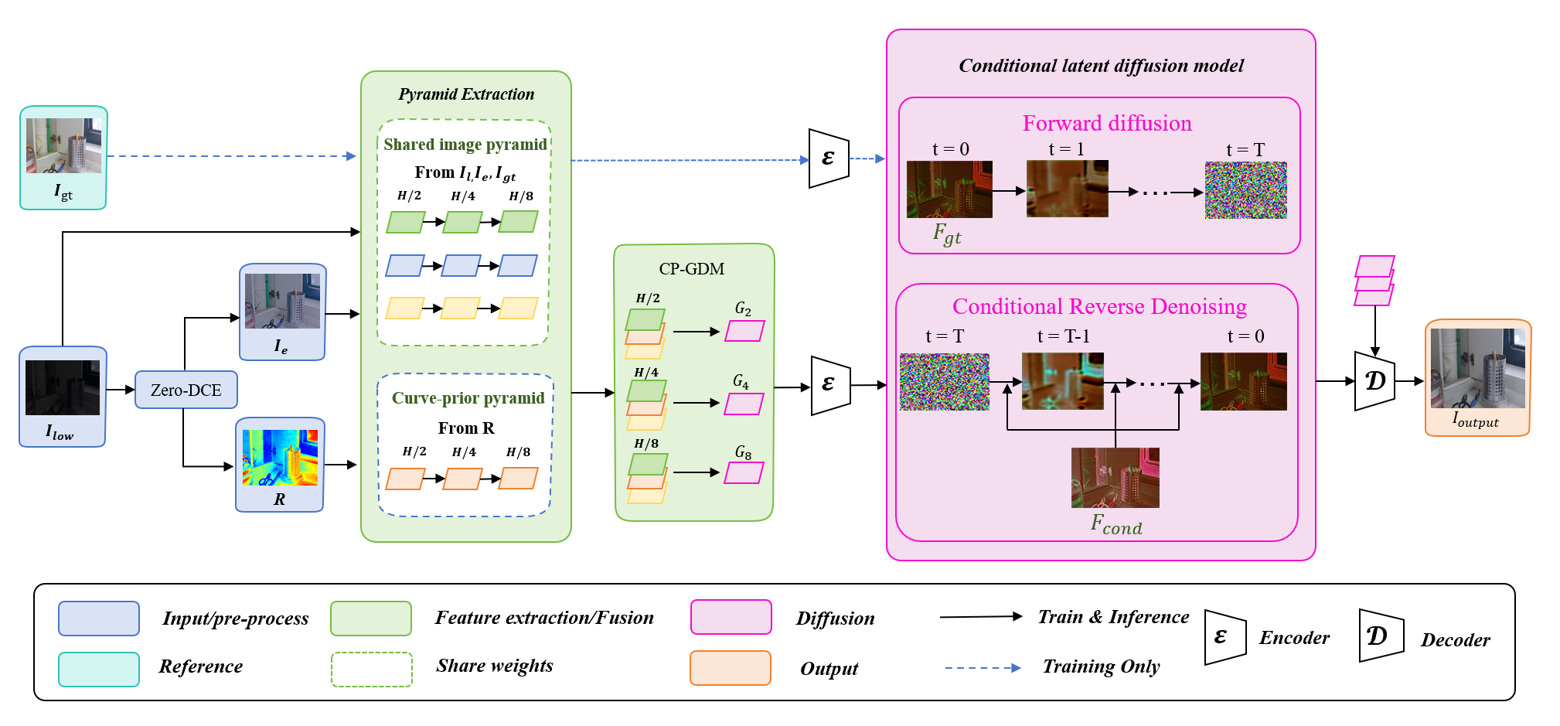
Fig. 1. Overall architecture of the proposed CPD-LDM.
3.2 Curve-Prior Dual-View Construction
Given a low-light image $I_{low}$, Zero-DCE [6] predicts eight groups of pixel-wise RGB curve parameters. These parameters are concatenated into a 24-channel curve map
$R=\left[r_{1},r_{2},…r_{8}\right], R∈{\left[-1,1\right]}^{B×24×H×W}$ (1)
where $r_{k}$ denotes the $k$-th group of three-channel RGB curve parameters, and $R$ is obtained by concatenating all eight groups along the channel dimension. $B$, $H$, and $W$ denote the batch size, image height, and image width, respectively, while $\left[-1,1\right]$ indicates the parameter range.
Starting from $I_{0}=I_{low}$, the enhancement curve is iteratively applied as
$I_{k}=I_{k-1}+r_{k}⊙\left(I_{k-1}^{2}-I_{k-1}\right), k=1,…,8,$ (2)
where $I_{k}$ denotes the enhanced image after the $k$-th curve adjustment, $k$ is the iteration index, and $⊙$ represents element-wise multiplication. The term $I_{k-1}^{2}$ denotes element-wise squaring. After eight iterations, the final result $I_{e}=I_{8}$ is used as the pre-enhanced view, while $R$ is retained as the curve prior.
The original low-light image $I_{low }$ and the pre-enhanced image $I_{e}$ form two complementary views. The former preserves the original structure and color relationships, whereas the latter improves dark-region visibility but may introduce amplified noise or local overexposure. Therefore, CPD-LDM retains both views instead of directly treating $I_{e}$ as the final result.
The Shared Image Pyramid, whose parameters are shared by the original-view, enhanced-view, and normal-light target paths, extracts three-scale features from the two input views:
$F_{l}^{s}=P_{s}\left(I_{low}\right), F_{e}^{s}=P_{s}\left(I_{e}\right), s∈\left\{2,4,8\right\}$ (3)
where $P_{s}$ denotes the shared image-pyramid operation at scale $s$. $F_{l}^{s}$ and $F_{e}^{s}$ represent the original-view and enhanced-view features, respectively, while $s∈\left\{2,4,8\right\}$ denotes the corresponding downsampling factor.
Meanwhile, an independent curve-prior pyramid encodes the 24-channel curve map:
$P_{R}^{s}=C_{s}\left(R\right), s∈\left\{2,4,8\right\}$ (4)
where $C_{s}$ denotes the curve-prior encoding operation at scale $s$, and $P_{R}^{s}$ represents the curve-prior feature derived from $R$. The corresponding channel dimensions are $C$, $2C$, and $4C$, where $C$ denotes the base channel dimension.
3.3 Curve-Prior-Guided Dual-View Fusion and Detail-Denoising Refinement
Although the original and enhanced views provide complementary information, the enhanced features may contain amplified noise, local overexposure, or color deviations. Therefore, CP-GDM performs curve-prior-guided dual-view fusion and detail-denoising refinement at each feature scale.
First, the difference between the original and enhanced features is calculated as
$D^{s}=F_{e}^{s}-F_{l}^{s}$ (5)
where $D^{s}$ denotes the feature difference between the enhanced view and the original low-light view at scale $s$.
A spatial fusion mask is then predicted by
$M^{s}=σ\left(H_{g}^{s}\left(\left[F_{l}^{s},F_{e}^{s},D^{s},P_{R}^{s}\right]\right)\right)$ (6)
where $M^{s}∈\left[0,1\right]$ denotes the spatial fusion mask at scale $s$. $\left[⋅\right]$ denotes channel-wise concatenation. The gate predictor $H_{g}^{s}$ consists of a $1×1$ pointwise convolution, a LeakyReLU activation, and a $3×3$ depthwise separable convolution, while $σ$ denotes the sigmoid function. The two views are combined using
$F_{g}^{s}=F_{l}^{s}+M^{s}⊙D^{s}$ (7)
where $F_{g}^{s}$ is the gated dual-view feature. A small value of $M^{s}$ preserves the original feature, whereas a large value emphasizes the enhanced feature. The curve prior further generates affine scale and bias parameters, which are bounded by a hyperbolic tangent function to prevent excessive modulation. A lightweight residual block then produces the refined fusion feature $F_{f}^{s}$.
To balance detail preservation and noise suppression, $F_{f}^{s}$ is decomposed into a low-frequency component $L^{s}$ and a high-frequency component $H^{s}$ using a $5×5$ local average filter. A reliability map $Q^{s}∈\left[0,1\right]$ is predicted from the curve prior, the absolute inter-view difference, and the high-frequency magnitude. Meanwhile, the high-frequency feature is processed by detail-preservation and denoising branches to generate $F_{det}^{s}$ and $F_{dn}^{s}$, respectively. The final output is defined as
$G_{s}=F_{f}^{s}+τ_{s}O_{s}\left[L^{s}+Q^{s}⊙F_{det}^{s}+\left(1-Q^{s}\right)⊙F_{dn}^{s}-F_{f}^{s}\right]$ (8)
where $G_{s}$ denotes the CP-GDM output, $O^{s}$ is a $1×1$ output projection, and $τ_{s}$ is a learnable residual scale initialized to 0.1. A large $Q^{s}$ favors detail preservation, while a small value emphasizes denoising. Applying CP-GDM at $H/2$, $H/4$, and$H/8$ resolutions produces $G_{2}$, $G_{4}$, and $G_{8}$, respectively, as illustrated in Fig. 2.
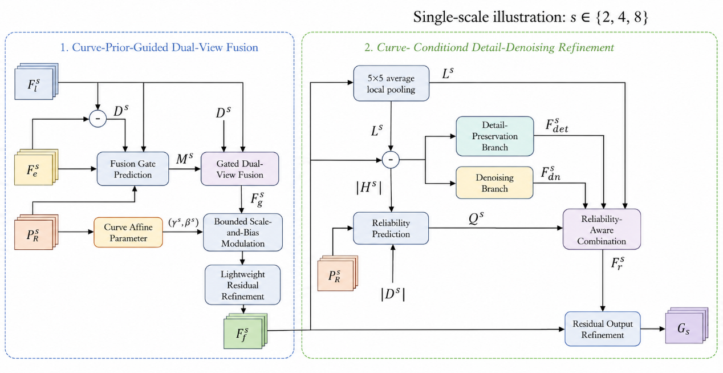
Fig. 2. Single-scale architecture of the proposed Curve-Prior-Guided Dual-View Fusion and Detail-Denoising Refinement Module (CP-GDM), where $s∈\left\{2,4,8\right\}$.
3.4 Shared Multi-Scale Latent Representation
To perform conditional diffusion, the conditional features and normal-light target features must have consistent spatial dimensions, numerical ranges, and feature semantics. CPD-LDM therefore employs a Shared Multi-Scale Encoder, denoted as the Encoder in Fig. 1, to project both feature paths into a common compact latent space.
During training, the Shared Image Pyramid extracts target features from $I_{gt}$ at resolutions of $H/2$, $H/4$, and $H/8$:
$T_{s}=P_{s}\left(I_{gt}\right) s∈\left\{2,4,8\right\}$ (9)
where $T_{s}$ represents its target feature at scale $s$.
The conditional path uses the guided features $G_{2}$, $G_{4}$, and $G_{8}$ generated by CP-GDM. These features are processed by the Shared Multi-Scale Encoder to obtain the conditional latent representation:
$F_{cond}=E\left(G_{2},G_{4},G_{8}\right)$ (10)
The target features are processed by the same Encoder to obtain the normal-light latent representation:
$F_{gt}=E\left(T_{2},T_{4},T_{8}\right)$ (11)
where $E$ denotes the Shared Multi-Scale Encoder, while $F_{cond}$ and $F_{gt}$ represent the conditional and target latent representations, respectively.
The two paths share all Encoder parameters. Multi-scale information is progressively propagated from the $H/2$ level to the $H/4$ and $H/8$ levels, while two bounded learnable gates regulate the contributions of shallow features and prevent them from dominating early training. The deepest feature is then projected into a three-channel representation at $H/8$ resolution, followed by Group Normalization and sigmoid activation to stabilize its numerical range.
Consequently, $F_{cond}$ and $F_{gt}$ have the same shape and value range but encode different information: $F_{cond}$ contains illumination and structural cues from the low-light input, whereas $F_{gt}$ represents the desired normal-light content. This shared encoding topology encourages the conditional and target features to form compatible latent representations and provides a stable target space for subsequent conditional diffusion.
The $I_{gt}$ path is used only during training and removed during inference, when only $F_{cond}$ is extracted. The latent space is learned by the proposed Encoder rather than obtained from a pretrained variational autoencoder.
3.5 Conditional Latent Diffusion and Guided Reconstruction
The Conditional Latent Diffusion Model learns to recover $F_{gt}$ under the guidance of $F_{cond}$. Performing diffusion at $H/8$ resolution reduces computational cost compared with pixel-space diffusion. Before diffusion, the two latent representations are linearly normalized to $\left[-1,1\right]$.
Following DDPM [13], Forward Diffusion progressively adds Gaussian noise to $F_{gt}$. The noisy feature at timestep $t$ is defined as
$F_{t}=\sqrt{{\overline{α}}_{t}}F_{gt}+\sqrt{1-{\overline{α}}_{t}}ϵ$ (12)
where $F_{t}$ denotes the noisy latent at timestep $t$, and $ϵ∼N\left(0,I\right)$ is Gaussian noise with identity covariance $I$. Given the noise variance $β_{t}$, $α_{t}=1-β_{t}$, while ${\overline{α}}_{t}$ denotes the cumulative product of $α_{t}$ up to timestep $t$. During training, $t$ is sampled from $\left\{1,…,T\right\}$, where $T$ is the total number of forward diffusion steps.
The diffusion U-Net takes the concatenated $F_{cond}$ and $F_{t}$ as input and predicts the added noise:
$\overset{ˆ}{ϵ}=ϵ_{θ}\left(\left[F_{cond},F_{t}\right],t\right)$ (13)
where $ϵ_{θ}$ denotes the noise estimator parameterized by $θ$, and $\overset{ˆ}{ϵ}$ is the predicted noise. The noise-prediction objective is defined as
$L_{noise}=E\left[{\left\|ϵ-\overset{ˆ}{ϵ}\right\|}_{2}^{2}\right]$ (14)

where $E\left[⋅\right]$ denotes expectation over the training samples, timesteps, and Gaussian noise, while ${\left\|⋅\right\|}_{2}$ is the $L_{2}$ norm.
During Conditional Reverse Denoising, the process starts from a Gaussian latent and progressively removes noise under the guidance of $F_{cond}$. After the selected reverse sampling trajectory, the generated representation is transformed back to $\left[0,1\right]$ and denoted as ${\overset{ˆ}{F}}_{gt}$. A sample-consistency loss directly constrains the final prediction:
$L_{scc}={\left\|{\overset{ˆ}{F}}_{gt}-F_{gt}\right\|}_{1}$ (15)
where ${\overset{ˆ}{F}}_{gt}$ denotes the predicted normal-light representation and ${\left\|⋅\right\|}_{1}$ is the $L_{1}$ norm. The noise-prediction loss supervises individual diffusion timesteps, whereas the sample-consistency loss constrains the final result of the reverse trajectory.
Finally, the predicted representation and the guided multi-scale features are delivered to the Decoder:
$I_{output}=D\left({\overset{ˆ}{F}}_{gt};G_{2},G_{4},G_{8}\right)$ (16)
where $D$ denotes the Decoder and $I_{output}$ is the reconstructed RGB image. The Decoder progressively restores spatial resolution and introduces $G_{2}$, $G_{4}$, and $G_{8}$ through bounded skip gates initialized to 0.1. These features provide illumination and structural guidance while preventing the Decoder from bypassing the predicted latent representation.
3.6 Training Objectives and Optimization Strategy
CPD-LDM is optimized using a two-stage training strategy. Stage I establishes a stable shared latent space and guided reconstruction network, while Stage II learns Conditional Reverse Denoising within the fixed latent space. This strategy prevents the target representation from changing while the diffusion U-Net is being optimized.
3.6.1 Stage-I Representation Learning
During Stage I, the pretrained Zero-DCE remains frozen, while Pyramid Extraction, CP-GDM, the Shared Multi-Scale Encoder, and the Decoder are jointly optimized using paired $I_{low}$ and $I_{gt}$. The Decoder maps $F_{gt}$ and $F_{cond}$ to the target-path reconstruction $I_{tar}$ and conditional-path reconstruction $I_{cond}$, respectively. Both paths use $G_{2}$, $G_{4}$, and $G_{8}$ as multi-scale guidance.
The reconstruction loss combines the Charbonnier loss and the structural similarity loss:
$L_{rec}\left(I,I_{gt}\right)=L_{char}\left(I,I_{gt}\right)+λ_{s}L_{ssim}\left(I,I_{gt}\right)$ (17)
where $I$ denotes either $I_{tar}$ or $I_{cond}$, $L_{char}$ and $L_{ssim}$ denote the Charbonnier and SSIM losses, respectively, and $λ_{s}$ controls their relative contribution.
To prevent the latent representations from collapsing into nearly constant features, a variance regularization term is introduced:
$L_{var}=\frac{1}{2}\left[\operatorname{ReLU}{​}\left(δ-\operatorname{Std}\left(F_{cond}\right)\right)+\operatorname{ReLU}{​}\left(δ-\operatorname{Std}\left(F_{gt}\right)\right)\right]$ (18)
where $\operatorname{Std}\left(⋅\right)$ denotes the standard deviation of a latent representation, $δ$ is the minimum standard-deviation threshold, and $\operatorname{ReLU}\left(⋅\right)$ penalizes only values below this threshold.
A color consistency loss is further applied to $I_{tar}$ to reduce global color deviations:
$L_{color}={\left\|μ\left(I_{tar}\right)-μ\left(I_{gt}\right)\right\|}_{1}+{\left\|σ\left(I_{tar}\right)-σ\left(I_{gt}\right)\right\|}_{1}$ (19)
where $μ\left(⋅\right)$ and $σ\left(⋅\right)$ denote the channel-wise mean and standard deviation. The complete Stage-I objective is defined as
$L_{stage1}=λ_{t}L_{rec}\left(I_{tar},I_{gt}\right)+λ_{c}L_{rec}\left(I_{cond},I_{gt}\right)+λ_{v}L_{var}+λ_{col}L_{color}$ (20)
where $λ_{t}$, $λ_{c}$, $λ_{v}$, and $λ_{col}$ are the weights of the target reconstruction, conditional reconstruction, variance regularization, and color consistency losses, respectively.
3.6.2 Stage-II Diffusion Learning
After Stage I, Zero-DCE, Pyramid Extraction, CP-GDM, the Shared Multi-Scale Encoder, and the Decoder are frozen. Only the diffusion U-Net is optimized using the fixed conditional and target representations. The Stage-II objective is defined as:
$L_{stage2}=kL_{noise}+lL_{scc}$ (21)
where $k$ and $l$ control the contributions of the noise-prediction and sample-consistency losses introduced in Section 3.5. Their relative setting is determined through the corresponding ablation experiment.
During inference, the $I_{gt}$ path and Forward diffusion are removed. The frozen representation network extracts $F_{cond}$ and the guided features from $I_{low}$. Conditional Reverse Denoising then produces ${\overset{ˆ}{F}}_{gt}$, which is reconstructed by the Decoder to obtain $I_{output}$.
4 Experiments
4.1 Experimental Setup
Implementation Details. The proposed method is implemented in PyTorch and trained on a single NVIDIA RTX 4090 GPU. Considering memory consumption and training stability, the batch size and patch size are set to 8 and 512×512, respectively. We use the Adam optimizer with a staged learning-rate schedule. In the first stage, the pretrained Zero-DCE is kept frozen, while Pyramid Extraction, CP-GDM, the Shared Multi-Scale Encoder, and the Decoder are jointly optimized with an initial learning rate of $1×{10}^{-4}$ , which is gradually decayed by a factor of 0.8. In the second stage, the parameters of the first-stage networks are frozen, and only the diffusion U-Net is optimized with the learning rate reset to $2×{10}^{-5}$. For the diffusion branch, a U-Net is adopted as the noise estimator, with the forward diffusion steps T and reverse sampling steps S set to 1000 and 20, respectively. To balance brightness restoration, structure preservation, and training stability, all loss weights are configured consistently with the settings described in the methodology section.
Datasets and Evaluation Metrics. We conduct experiments on three paired low-light image datasets: LOL-v1 [3], LOL-v2-Real [29], and LOL-v2-Synthetic [29]. For the evaluation on LOL-v1 and LOL-v2-Real, we construct a mixed training set by combining the official LOL-v1 training split with paired samples selected exclusively from the official LOL-v2-Real training split. A single model is trained on this mixed dataset and then independently evaluated on the untouched official test sets of LOL-v1 and LOL-v2-Real. No images from either test set are used for training or fine-tuning. For LOL-v2-Synthetic, we train a separate model using only its official training split and evaluate it on the corresponding official test split. Therefore, the results on LOL-v1 and LOL-v2-Real are produced by the jointly trained model, whereas the results on LOL-v2-Synthetic are obtained using the separately trained synthetic-data model. Since all these test sets provide normal-light reference images, peak signal-to-noise ratio (PSNR), structural similarity index (SSIM) [30], and learned perceptual image patch similarity (LPIPS) [31] are employed as quantitative metrics.
4.2 Experimental Comparison
Comparison Methods. To validate the effectiveness of the proposed method, several representative low-light image enhancement methods are selected for comparison, including Zero-DCE [6], Zero-DiDCE [28], RUAS [7], RetinexNet [3], PairLIE [16], LightenDiffusion [19], URetinex-Net [10], HVI-CIDNet [23], LLIEFormer [26], LLFormer [27], and SNR-Aware [9]. These methods cover different technical paradigms, including Retinex decomposition, zero-reference curve estimation, deep unfolding, diffusion modeling, and supervised Transformer-based restoration, thereby providing a comprehensive evaluation of brightness restoration, structural preservation, and perceptual quality. All comparison results are obtained using the publicly available implementations or official pretrained models and are evaluated on the corresponding test sets using the same metric computation protocol.
Table 1 presents the quantitative comparison results on the LOL-v1, LOL-v2-Real, and LOL-v2-Synthetic datasets. The best and second-best results are highlighted according to the formatting requirements of the target journal. Since the compared methods adopt different enhancement mechanisms and may exhibit different preferences among pixel fidelity, structural similarity, and perceptual quality, the results are analyzed separately for each dataset and metric.
Table 1. Quantitative comparisons on LOL-v1, LOL-v2-Real, and LOL-v2-Synthetic.
Method | LOL-v1 |  |  | LOL-v2-Real |  |  | LOL-v2-Synthetic
 | PSNR↑ | SSIM↑ | LPIPS↓ | PSNR↑ | SSIM↑ | LPIPS↓ | PSNR↑ | SSIM↑ | LPIPS↓
Zero-DCE [6] | 14.8607 | 0.5588 | 0.3351 | 18.0588 | 0.5736 | 0.3125 | 17.7564 | 0.8163 | 0.1681
Zero-DiDCE [28] | 17.9406 | 0.5765 | 0.3277 | 19.4332 | 0.5594 | 0.3379 | 17.5739 | 0.8036 | 0.1653
RUAS [7] | 16.4047 | 0.4996 | 0.2701 | 15.3255 | 0.4876 | 0.3097 | 18.3741 | 0.7237 | 0.2639
RetinexNet [3] | 17.5441 | 0.6484 | 0.3823 | 17.6583 | 0.6461 | 0.4444 | 17.3071 | 0.7439 | 0.2734
PairLIE [16] | 18.4684 | 0.7473 | 0.2435 | 19.8845 | 0.7777 | 0.2341 | 19.0744 | 0.7965 | 0.2300
LightenDiffusion [19] | 19.9451 | 0.8119 | 0.1800 | 22.7723 | 0.8539 | 0.1665 | 21.6448 | 0.8680 | 0.1553
URetinex-Net [10] | 20.1406 | 0.8235 | 0.1265 | 19.7802 | 0.8429 | 0.1078 | 18.7705 | 0.8241 | 0.1908
HVI-CIDNet [23] | 23.8085 | 0.8574 | 0.0856 | 23.2262 | 0.8637 | 0.1075 | 25.1290 | 0.9388 | 0.0450
LLIEFormer [26] | 23.0311 | 0.8275 | 0.1562 | 25.7828 | 0.8799 | 0.1255 | - | - | -
LLFormer [27] | 23.6487 | 0.8185 | 0.1692 | 27.7497 | 0.8611 | 0.1428 | 23.2413 | 0.8942 | 0.0856
SNR-Aware [9] | 24.6085 | 0.8419 | 0.1510 | 21.4788 | 0.8489 | 0.1568 | 24.1379 | 0.9279 | 0.0558
Ours | 24.6837 | 0.8406 | 0.1220 | 25.7775 | 0.8756 | 0.1025 | 25.3052 | 0.9125 | 0.0672
Results on LOL-v1. The proposed method achieves a PSNR of 24.6837 dB on LOL-v1, obtaining the best result among the compared methods and exceeding SNR-Aware by 0.0752 dB. It also obtains an LPIPS value of 0.1220, which is the second-best result in Table 1 and is substantially lower than those of most conventional, zero-reference, and Transformer-based approaches. Although its SSIM of 0.8406 is slightly lower than those of HVI-CIDNet and SNR-Aware, it remains competitive. These results demonstrate that the proposed method provides a favorable balance between pixel-level reconstruction accuracy and perceptual similarity instead of optimizing only a single quality criterion.
Results on LOL-v2-Real. On LOL-v2-Real, the proposed method obtains 25.7775 dB in PSNR, 0.8756 in SSIM, and 0.1025 in LPIPS. Its PSNR is competitive with the recent supervised methods, while its SSIM ranks second among the reported results. More importantly, the proposed method achieves the lowest LPIPS value, outperforming HVI-CIDNet, URetinex-Net, LLIEFormer, and LLFormer in perceptual similarity. The strong LPIPS performance indicates that the curve-guided dual-view representation and latent diffusion refinement can reduce perceptually noticeable distortions while recovering the illumination and structural information of real low-light images.
Results on LOL-v2-Synthetic. The proposed method achieves the highest PSNR of 25.3052 dB on LOL-v2-Synthetic, surpassing HVI-CIDNet by 0.1762 dB. It also produces competitive SSIM and LPIPS values of 0.9125 and 0.0672, respectively. HVI-CIDNet and SNR-Aware obtain better SSIM or LPIPS results on this dataset, indicating that their specialized representations retain certain advantages in structural or perceptual similarity. Nevertheless, the superior PSNR of the proposed method demonstrates its effectiveness in restoring global illumination and reducing pixel-level reconstruction errors under synthetically generated degradation. The results also reveal that the proposed method favors a balanced reconstruction rather than achieving uniform superiority on every metric.
Overall, the proposed method achieves the best PSNR on LOL-v1 and LOL-v2-Synthetic and the best LPIPS on LOL-v2-Real, while maintaining competitive performance on the remaining metrics. The results across three datasets demonstrate that the proposed method provides stable enhancement performance for both real and synthetic low-light degradation. More specifically, the curve-prior-guided dual-view representation contributes to exposure correction, whereas latent diffusion refinement improves perceptual quality and reduces residual restoration errors.

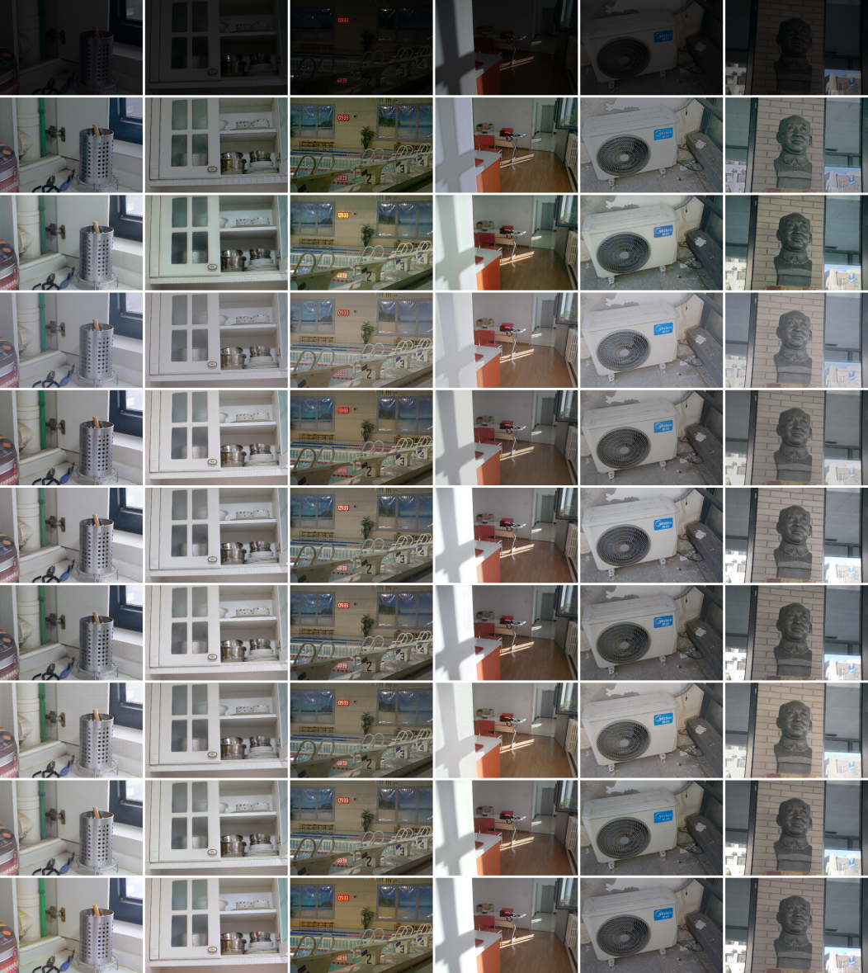
LLFormer
Ground Truth
Ours
SNR-Aware
LLIEFormer
HVI-CIDNet
URetinex-Net
LightenDiffusion
Zero-DCE
Input
Fig. 3. Visual comparisons with state-of-the-art LLIE methods on the LOL benchmark datasets.
Qualitative comparison. Figure 3 presents visual comparisons on representative images from the LOL test sets. Several comparison methods leave severely dark regions insufficiently enhanced or introduce over-enhancement in originally bright areas. For example, inaccurate exposure correction can cause the white regions around cabinets, walls, and air conditioners to become washed out, while insufficient restoration makes object boundaries and surface textures difficult to distinguish. Some methods also introduce noticeable color shifts or amplify noise in shadow regions.
In contrast, the proposed method produces more spatially balanced illumination and maintains a closer visual appearance to the ground-truth images. It restores the boundaries of cabinets and indoor objects, preserves the structural patterns of the air-conditioner grille, and retains surface details in the statue and outdoor scenes. The proposed method also alleviates excessive brightness amplification in high-illumination regions, demonstrating that the curve prior can provide spatially adaptive exposure guidance. Meanwhile, the latent diffusion module further refines structural details and suppresses residual artifacts. These observations are consistent with the quantitative improvements in PSNR and LPIPS.
4.3 Ablation Study
To investigate the contribution of each component in the proposed framework, we conduct a series of controlled ablation experiments. The experiments mainly examine the effectiveness of the Zero-DCE enhanced view, curve-prior-guided fusion, curve-conditioned detail-denoising refinement, and latent diffusion restoration. We further analyze the influence of the sample-consistency loss weight on the final enhancement performance. Unless otherwise specified, all variants are trained and evaluated using the same dataset splits, optimization settings, training epochs, and evaluation protocol. Only the component under investigation is modified in each experiment.
Effectiveness of individual components. Five model configurations, denoted as M1–M5, are constructed to progressively evaluate the proposed components. M1 is a single-view baseline that uses only the original low-light image without introducing the Zero-DCE branch. M2 introduces the enhanced view generated by the frozen Zero-DCE model and performs ordinary dual-view feature fusion without curve-prior guidance. M3 further incorporates the multi-scale curve prior and curve-guided cross-view gating. M4 adds the curve-conditioned detail-denoising refinement module to M3 and represents the complete Stage-I reconstruction network. Finally, M5 integrates the conditional latent diffusion model into M4 and represents the complete proposed framework.
Table 2. Component ablation results on LOL-v1 and LOL-v2-Real.
 | LOL-v1 |  |  | LOL-v2-Real
Variant | PSNR↑ | SSIM↑ | LPIPS↓ | PSNR↑ | SSIM↑ | LPIPS↓
M1 | 21.0354 | 0.8138 | 0.1532 | 22.0025 | 0.8367 | 0.1426
M2 | 22.9779 | 0.8342 | 0.1241 | 24.6021 | 0.8629 | 0.1054
M3 | 23.4444 | 0.8348 | 0.1256 | 24.8959 | 0.8639 | 0.1065
M4 | 23.8854 | 0.8399 | 0.1269 | 25.1117 | 0.8647 | 0.1056
M5 | 24.6837 | 0.8406 | 0.1220 | 25.7775 | 0.8756 | 0.1025
As summarized in Table 2, the introduction of the Zero-DCE enhanced view (M2) yields the most substantial improvement over M1, increasing PSNR by 1.94 dB on LOL-v1 and 2.60 dB on LOL-v2-Real, with corresponding gains in SSIM and LPIPS. Curve-prior-guided fusion (M3) contributes additional PSNR improvements of 0.47 dB and 0.29 dB, confirming the spatial guidance provided by the curve parameters. The slight increase in LPIPS for M3 suggests that its primary advantage lies in exposure correction rather than perceptual similarity. The detail-denoising module (M4) further improves reconstruction fidelity, although a minor LPIPS fluctuation is observed on LOL-v1. Finally, the conditional latent diffusion module (M5) consistently enhances all metrics, adding 0.80 dB in PSNR and lowering LPIPS from 0.1269 to 0.1220 on LOL-v1. Overall, the progressive performance gains demonstrate the complementary contributions of each component.
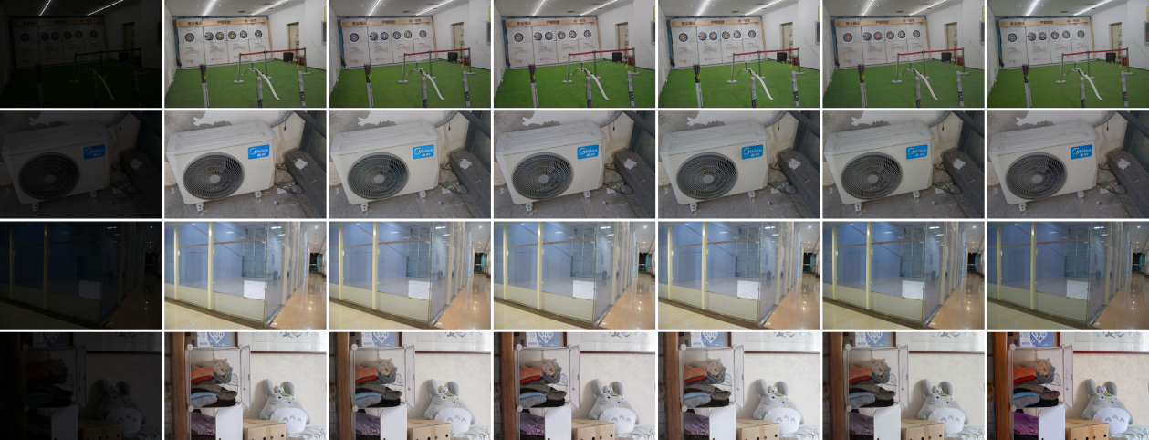
Low-light input M1 M2 M3 M4 M5 Ground Truth
Fig. 4. Visual comparison of the component-ablation variants M1–M5.
Figure 4 further presents the visual differences among the five configurations. M1 improves the overall visibility but still exhibits insufficient illumination recovery and unclear local structures in severely dark regions. By introducing the Zero-DCE enhanced view, M2 produces a more evident brightness improvement, although some regions remain spatially inconsistent. M3 achieves more adaptive illumination correction by using the curve prior to guide cross-view fusion. M4 further improves the boundaries and local textures of objects while suppressing noise amplification in dark regions. The complete M5 model produces results closest to the ground truth, with more balanced illumination, clearer structural details, and fewer visible artifacts. The visual observations are consistent with the quantitative results in Table 2.
Effect of the $L_{scc}$ weight. The Stage-II diffusion objective contains a noise-prediction loss and a sample-consistency loss, weighted by $k$ and $l$, respectively. To investigate the influence of $L_{scc}$, we fix the noise-loss weight as $k$ and vary the $L_{scc}$ weight $l$ over {0, 1, 2, 3, 4, 5}. All other training and inference settings remain unchanged.
Table 3. Effect of the sample-consistency loss weight ratio $l/k$ on three LOL benchmarks.
$l$/k | LOL-v1 |  |  | LOL-v2-Real |  |  | LOL-v2-Synthetic
 | PSNR↑ | SSIM↑ | LPIPS↓ | PSNR↑ | SSIM↑ | LPIPS↓ | PSNR↑ | SSIM↑ | LPIPS↓
0 | 12.1027 | 0.5326 | 0.3424 | 10.5688 | 0.5099 | 0.4338 | 10.7577 | 0.4880 | 0.5432
1 | 24.3415 | 0.8428 | 0.1213 | 25.8233 | 0.8755 | 0.1019 | 24.9701 | 0.9102 | 0.0698
2 | 24.0144 | 0.8301 | 0.1274 | 23.9629 | 0.8650 | 0.1067 | 25.0699 | 0.9121 | 0.0688
3 | 24.6837 | 0.8406 | 0.1220 | 25.7775 | 0.8756 | 0.1025 | 25.3052 | 0.9125 | 0.0672
4 | 24.3102 | 0.8401 | 0.1222 | 25.3374 | 0.8737 | 0.1033 | 25.0253 | 0.9134 | 0.0600
5 | 23.7497 | 0.8307 | 0.1273 | 24.8737 | 0.8713 | 0.1036 | 25.0632 | 0.9109 | 0.0690
Table 3 investigates the effect of the loss-weight ratio $l/k$. When $l/k=0$, the model exhibits substantial performance degradation on all three datasets, indicating that the sample-consistency constraint is important for recovering the target latent representation. Compared with $l/k=0$, all nonzero settings produce substantial improvements, while the performance varies non-monotonically across different positive ratios. The setting $l/k=3$ achieves the highest PSNR on LOL-v1 and LOL-v2-Synthetic, while maintaining competitive SSIM and LPIPS performance. On LOL-v1, $l/k=1$ obtains the highest SSIM and lowest LPIPS, whereas $l/k=3$ improves PSNR from 24.3415 to 24.6837 dB. On LOL-v2-Real, $l/k=1$ achieves the highest PSNR and lowest LPIPS, while $l/k=3$ obtains the highest SSIM with only a 0.0458 dB PSNR difference. Although $l/k=4$ produces the best SSIM and LPIPS on LOL-v2-Synthetic, its performance decreases on LOL-v1 and LOL-v2-Real. Therefore, $l/k=3$ is selected as the default setting because it provides the most consistent balance among pixel fidelity, structural similarity, and perceptual quality across the three datasets.
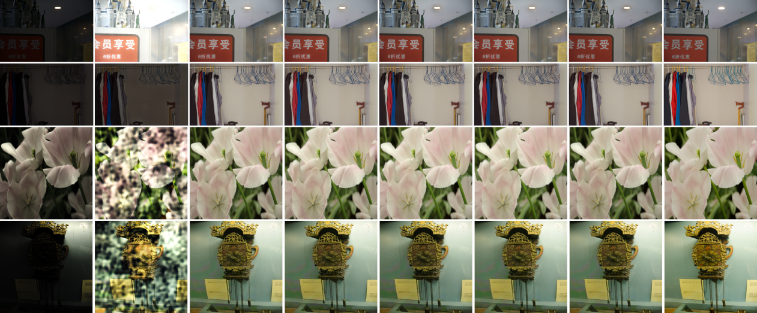
input 0 1 2 3 4 5 Ground Truth
Fig. 5. Visual comparison under different sample-consistency loss weight ratios $\frac{l}{k}$.
The visual results in Figure 5 are consistent with the quantitative observations. Without the SCC loss, the model produces severe exposure errors, color distortions, and unstable structural content. After introducing sample-consistency loss, the reconstructed images exhibit more natural illumination and clearer object boundaries. A moderate value of $l$ effectively constrains the generated latent representation without excessively weakening noise-prediction learning. In comparison, overly large $L_{scc}$ weights may place excessive emphasis on feature alignment and reduce the flexibility of the diffusion model. The setting $l/k=3$ provides a favorable visual balance among brightness restoration, detail preservation, and artifact suppression.
Effect of diffusion sampling steps. To investigate the trade-off between restoration quality and inference efficiency, we evaluate the proposed model using 5, 10, 20, and 50 reverse sampling steps on LOL-v2-Real and LOL-v2-Synthetic. The same trained model, forward noise schedule, and inference settings are used for all configurations, with only the number of reverse sampling steps changed. Each configuration is evaluated using three random seeds, and the mean results are reported in Table 4.
Table 4. Effect of reverse diffusion sampling steps on LOL-v2-Real and LOL-v2-Synthetic. Results are reported as mean over three random seeds.
 | LOL-v2-Real |  |  |  | LOL-v2-Synthetic
steps | PSNR↑ | SSIM↑ | LPIPS↓ | Time/image(s)↓ | PSNR↑ | SSIM↑ | LPIPS↓ | Time/image(s)↓
5 | 13.6193 | 0.6246 | 0.3754 | 0.1059 | 13.4789 | 0.6256 | 0.4077 | 0.0724
10 | 23.7181 | 0.8614 | 0.1175 | 0.1381 | 23.9870 | 0.9047 | 0.0767 | 0.1129
20 | 25.7775 | 0.8756 | 0.1025 | 0.2141 | 25.3052 | 0.9125 | 0.0672 | 0.1780
50 | 15.7959 | 0.6936 | 0.2967 | 0.4282 | 14.4314 | 0.6727 | 0.3459 | 0.3803
As shown in Table 4, increasing the reverse sampling steps from 5 to 20 consistently improves restoration quality on both LOL-v2-Real and LOL-v2-Synthetic. The 20-step configuration achieves the best overall performance, indicating that an excessively short reverse trajectory is insufficient to progressively recover a stable normal-light latent representation. Meanwhile, the increase in sampling steps introduces only a moderate computational cost, with the inference time remaining acceptable at 20 steps.
Further increasing the sampling steps to 50, however, leads to a substantial performance decrease. Since different numbers of sampling steps correspond to different timestep intervals in the reverse trajectory, the denser 50-step sequence may not be well matched to the denoising transitions learned under the current noise schedule. The resulting prediction deviations may subsequently propagate through successive reverse updates. This degradation is specific to the adopted sampling configuration and does not imply that a larger number of diffusion steps is inherently detrimental. Considering both reconstruction quality and inference efficiency, 20 reverse sampling steps are adopted in all subsequent experiments.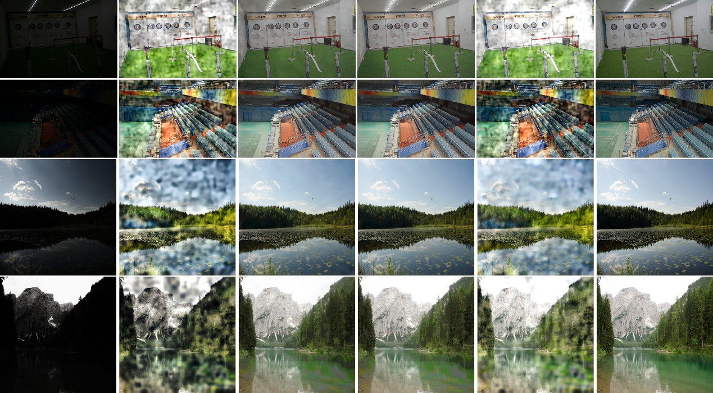
Input 5 steps 10 steps 20 steps 50 steps Ground Truth
Fig. 6. Visual comparison under different numbers of reverse diffusion sampling steps. From left to right: low-light input, 5 steps, 10 steps, 20 steps, 50 steps, and ground truth.
Figure 6 further confirms this trend visually. The 5-step results contain noticeable exposure and structural errors, while 10 steps substantially improve illumination recovery. The 20-step setting produces more coherent structures, natural illumination, and stable colors. In contrast, the 50-step results exhibit renewed texture corruption and color inconsistency, consistent with the quantitative degradation in Table 4.
5 Conclusion
In this paper, we proposed CPD-LDM, a Curve-Prior-Guided Dual-View Latent Diffusion Model for low-light image enhancement. A frozen Zero-DCE model generates a pre-enhanced view and pixel-wise curve priors, which are used to guide dual-view feature fusion and reliability-aware detail-denoising refinement. A shared multi-scale encoder projects the conditional and target features into a unified latent space, where conditional diffusion restores the normal-light representation and a guided decoder reconstructs the final enhanced image. Experiments on LOL-v1, LOL-v2-Real, and LOL-v2-Synthetic demonstrate that the proposed method achieves competitive quantitative performance while producing more balanced illumination, clearer structures, and fewer artifacts. The ablation studies further verify the effectiveness of the main components.
The current framework still relies on paired low- and normal-light images for supervised training, which may limit its applicability to more diverse real-world scenarios. Future work will therefore investigate unsupervised and weakly supervised learning strategies to reduce the dependence on paired reference data. In addition, more effective curve-aware condition-guidance mechanisms will be explored to improve the utilization of spatial exposure priors, while more robust detail-denoising strategies will be developed for severe noise and complex illumination conditions.
6 References
- Jobson, D.J., Rahman, Z., Woodell, G.A.: A multiscale Retinex for bridging the gap between color images and the human observation of scenes. IEEE Trans. Image Process. 6(7), 965–976 (1997). https://doi.org/10.1109/83.597272
- Guo, X., Li, Y., Ling, H.: LIME: low-light image enhancement via illumination map estimation. IEEE Trans. Image Process. 26(2), 982–993 (2017). https://doi.org/10.1109/TIP.2016.2639450
- Wei, C., Wang, W., Yang, W., et al.: Deep Retinex decomposition for low-light enhancement. In: British Machine Vision Conference 2018 (BMVC), p. 155. BMVA Press (2018)
- Zhang, Y., Zhang, J., Guo, X.: Kindling the darkness: a practical low-light image enhancer. In: Proceedings of the 27th ACM International Conference on Multimedia, pp. 1632–1640 (2019). https://doi.org/10.1145/3343031.3350926
- Jiang, Y., Gong, X., Liu, D., et al.: EnlightenGAN: deep light enhancement without paired supervision. IEEE Trans. Image Process. 30, 2340–2349 (2021). https://doi.org/10.1109/TIP.2021.3051462
- Guo, C., Li, C., Guo, J., et al.: Zero-reference deep curve estimation for low-light image enhancement. In: Proceedings of the IEEE/CVF Conference on Computer Vision and Pattern Recognition (CVPR), pp. 1780–1789 (2020). https://doi.org/10.1109/CVPR42600.2020.00185
- Liu, R., Ma, L., Zhang, J., et al.: Retinex-inspired unrolling with cooperative prior architecture search for low-light image enhancement. In: Proceedings of the IEEE/CVF Conference on Computer Vision and Pattern Recognition (CVPR), pp. 10561–10570 (2021). https://doi.org/10.1109/CVPR46437.2021.01042
- Ma, L., Ma, T., Liu, R., et al.: Toward fast, flexible, and robust low-light image enhancement. In: Proceedings of the IEEE/CVF Conference on Computer Vision and Pattern Recognition (CVPR), pp. 5637–5646 (2022). https://doi.org/10.1109/CVPR52688.2022.00555
- Xu, X., Wang, R., Fu, C.-W., et al.: SNR-aware low-light image enhancement. In: Proceedings of the IEEE/CVF Conference on Computer Vision and Pattern Recognition (CVPR), pp. 17714–17724 (2022). https://doi.org/10.1109/CVPR52688.2022.01719
- Wu, W., Weng, J., Zhang, P., et al.: URetinex-Net: Retinex-based deep unfolding network for low-light image enhancement. In: Proceedings of the IEEE/CVF Conference on Computer Vision and Pattern Recognition (CVPR), pp. 5901–5910 (2022). https://doi.org/10.1109/CVPR52688.2022.00581
- Wang, Y., Wan, R., Yang, W., et al.: Low-light image enhancement with normalizing flow. Proc. AAAI Conf. Artif. Intell. 36(3), 2604–2612 (2022). https://doi.org/10.1609/aaai.v36i3.20162
- Cai, Y., Bian, H., Lin, J., et al.: Retinexformer: one-stage Retinex-based transformer for low-light image enhancement. In: Proceedings of the IEEE/CVF International Conference on Computer Vision (ICCV), pp. 12504–12513 (2023). https://doi.org/10.1109/ICCV51070.2023.01149
- Ho, J., Jain, A., Abbeel, P.: Denoising diffusion probabilistic models. Adv. Neural Inf. Process. Syst. 33, 6840–6851 (2020)
- Yi, X., Xu, H., Zhang, H., et al.: Diff-Retinex: rethinking low-light image enhancement with a generative diffusion model. In: Proceedings of the IEEE/CVF International Conference on Computer Vision (ICCV), pp. 12302–12311 (2023). https://doi.org/10.1109/ICCV51070.2023.01130
- Wang, Y., Yu, Y., Yang, W., et al.: ExposureDiffusion: learning to expose for low-light image enhancement. In: Proceedings of the IEEE/CVF International Conference on Computer Vision (ICCV), pp. 12438–12448 (2023). https://doi.org/10.1109/ICCV51070.2023.01143
- Fu, Z., Yang, Y., Tu, X., et al.: Learning a simple low-light image enhancer from paired low-light instances. In: Proceedings of the IEEE/CVF Conference on Computer Vision and Pattern Recognition (CVPR), pp. 22252–22261 (2023). https://doi.org/10.1109/CVPR52729.2023.02131
- Wang, W., Yang, H., Fu, J., et al.: Zero-reference low-light enhancement via physical quadruple priors. In: Proceedings of the IEEE/CVF Conference on Computer Vision and Pattern Recognition (CVPR), pp. 26057–26066 (2024). https://doi.org/10.1109/CVPR52733.2024.02462
- Li, J., Li, B., Tu, Z., et al.: Light the night: a multi-condition diffusion framework for unpaired low-light enhancement in autonomous driving. In: Proceedings of the IEEE/CVF Conference on Computer Vision and Pattern Recognition (CVPR), pp. 15205–15215 (2024). https://doi.org/10.1109/CVPR52733.2024.01440
- Jiang, H., Luo, A., Liu, X., et al.: LightenDiffusion: unsupervised low-light image enhancement with latent-Retinex diffusion models. In: Computer Vision—ECCV 2024, pp. 161–179. Springer, Cham (2024). https://doi.org/10.1007/978-3-031-73195-2_10
- Shi, Y., Liu, D., Zhang, L., et al.: ZERO-IG: zero-shot illumination-guided joint denoising and adaptive enhancement for low-light images. In: Proceedings of the IEEE/CVF Conference on Computer Vision and Pattern Recognition (CVPR), pp. 3015–3024 (2024). https://doi.org/10.1109/CVPR52733.2024.00291
- Feng, Y., Hou, S., Lin, H., et al.: DiffLight: integrating content and detail for low-light image enhancement. In: Proceedings of the IEEE/CVF Conference on Computer Vision and Pattern Recognition Workshops (CVPRW), pp. 6143–6152 (2024). https://doi.org/10.1109/CVPRW63382.2024.00619
- Wu, W., Weng, J., Zhang, P., et al.: Interpretable optimization-inspired unfolding network for low-light image enhancement. IEEE Trans. Pattern Anal. Mach. Intell. 47(4), 2545–2562 (2025). https://doi.org/10.1109/TPAMI.2024.3524538
- Yan, Q., Feng, Y., Zhang, C., et al.: HVI: a new color space for low-light image enhancement. In: Proceedings of the IEEE/CVF Conference on Computer Vision and Pattern Recognition (CVPR), pp. 5678–5687 (2025). https://doi.org/10.1109/CVPR52734.2025.00533
- Qaisar, Z.H., Khan, R., Mehmood, A., et al.: A deep adaptive framework for low-light image enhancement in adverse lighting conditions. Vis. Comput. 41, 12109–12124 (2025). https://doi.org/10.1007/s00371-025-04147-6
- Sen, S.Y., Turkan, M., Alankus, G.: Low-light image enhancement: a multi-stage hybrid approach via Retinex and vision transformers. Vis. Comput. 42, Article 270 (2026). https://doi.org/10.1007/s00371-026-04485-z
- Yi, X., Wang, Y., Zhao, Y., et al.: LLIEFormer: a low-light image enhancement transformer network with a degraded restoration model. In: Proceedings of the IEEE International Conference on Image Processing (ICIP), pp. 1195–1199 (2023). https://doi.org/10.1109/ICIP49359.2023.10222840
- Wang, T., Zhang, K., Shen, T., et al.: Ultra-high-definition low-light image enhancement: a benchmark and transformer-based method. Proc. AAAI Conf. Artif. Intell. 37(3), 2654–2662 (2023). https://doi.org/10.1609/aaai.v37i3.25364
- Mi, A., Luo, W., Qiao, Y., et al.: Rethinking Zero-DCE for low-light image enhancement. Neural Process. Lett. 56, Article 93 (2024). https://doi.org/10.1007/s11063-024-11565-5
- Yang, W., Wang, S., Fang, Y., et al.: From fidelity to perceptual quality: a semi-supervised approach for low-light image enhancement. In: Proceedings of the IEEE/CVF Conference on Computer Vision and Pattern Recognition (CVPR), pp. 3063–3072 (2020). https://doi.org/10.1109/CVPR42600.2020.00313
- Wang, Z., Bovik, A.C., Sheikh, H.R., et al.: Image quality assessment: from error visibility to structural similarity. IEEE Trans. Image Process. 13(4), 600–612 (2004). https://doi.org/10.1109/TIP.2003.819861
- Zhang, R., Isola, P., Efros, A.A., et al.: The unreasonable effectiveness of deep features as a perceptual metric. In: Proceedings of the IEEE/CVF Conference on Computer Vision and Pattern Recognition (CVPR), pp. 586–595 (2018). https://doi.org/10.1109/CVPR.2018.00068

